**EIT InnoEnergy becomes Nabrawind shareholder**

**News 12/09/2019**

[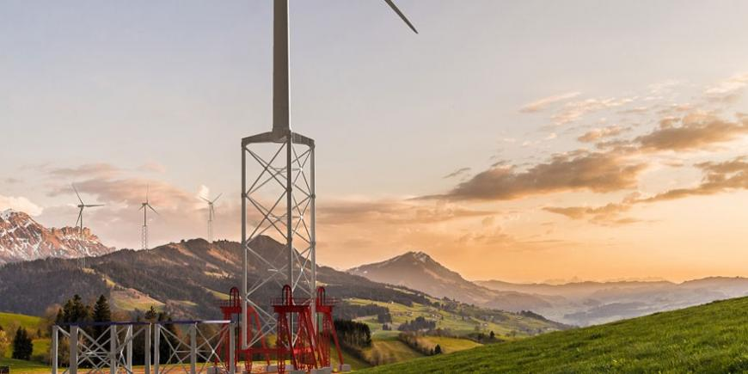](https://eit.europa.eu/sites/default/files/eit-innoenergy-nabrawind.jpg)

**Nabrawind Technologies develops advanced wind technologies for wind turbine components.**

[EIT InnoEnergy](https://eit.europa.eu/our-communities/eit-innoenergy) has agreed to join the shareholding at [Nabrawind Technologies](https://www.nabrawind.com/company/), increasing their support that started in 2018. The Spanish company completed last month, in the same operation, a capital increase of EUR 1 175 000 with the recent entry of Basarro 2005 S.L. in its shareholding, which joins Nabrawind SL, Barinaga&Alberdi SA and Sodena SL.

This new round complements the second contribution made by the initial partners in 2018 that amounted to EUR 1.5 million.

Shortly before closing this operation, the Spanish company also received a grant from the [Horizon 2020 SME Instrument programme](https://ec.europa.eu/programmes/horizon2020/en/area/smes) of EUR 1.7 million. Therefore, the financial situation of Nabrawind Technologies has considerably strengthened and allows the company to face with guarantees the market entry phase that started this very same year.

**Plans for the future**

After the prototypes phase in 2018, it was recently announced that in 2020 Nabrawind will also install the tallest tower in Africa (144 m high). Nevertheless, and according to its development plan, the Spanish team is already working on self-erecting towers that exceed 200 m high, which will become a global 'wind roof'. Likewise, very advanced contacts are being maintained with the main players of the wind sector for the installation of their two solutions, both modular blade and self-erecting tower, planned for 2020 and 2021.

*The profile of the new partners has prevailed. One of them with a deep presence in Navarre and recognised industrial trajectory, the other one with an outstanding knowledge of the wind sector. Their presence will provide additional added value, beyond mere financial support, which is also important.*

*Eneko Sanz, General Manager of Nabrawind Technologies*